# Coursera Data Science Capstone Project (Accident Severity)

Hugh Chua

19/9/2020

## Introduction

### Background

### Traffic accidents occur daily all around the world. According to the World Health Organization, over 1.35 million people die every year due to road traffic crashes. Traffic accidents cost most countries 3% of their GDP. Therefore, it is clearly in different countries’ interest to reduce the number of vehicle crashes by preventing them from happening in the first place. Reducing the number of automobile accidents can minimize the number of lives lost and the yearly cost of road repairs, which is paid for by taxpayers.

### The severity of the accident is important as well. Even though traffic accidents can be catastrophic, the vast majority of accidents registered are not severe at all and could constitute a small scratch on a car. It is essential to distinguish these sorts of accidents from very severe accidents where there is substantial damage to human wellbeing and property.

### Problem

### This project aims to determine whether knowledge of a junction near the accident site would be able to predict better the likelihood of an accident occurring and the severity. It is widely believed that accidents happen when vehicles change lane or move into a different road, so it would be an interesting aspect to explore. The project could be validated by running two sets of data through the machine learning models. One would have the junction attributes, and one would not have them. The dependent factor would be the number of cases and the corresponding accident severity.

### Interest

## This project could be helpful to multiple parties. Real-time mapping services could use this model to predict accident hotspots and give suitable recommendations to the drivers. Drivers who follow the guidance could potentially avoid a traffic accident and could avert potential property and human damage costs. The roadway authorities determine the accident blackspots in the area and make the necessary changes. Non-government organizations or governments of economically less developed countries could use this data to better design roads in developing countries.

## Data

### Data sources

The data set used for this project was found on Kaggle here (<https://www.kaggle.com/akshay4/road-accidents-incidence>). This dataset captured road accidents in the UK between 1979 and 2015 and was originally from the Open Data Platform UK. There are more than 70 features and roughly 250k rows. All the categories in the dataset have numbers that denote the particular category within the feature, so there is an additional CSV file that explains what the different numbers mean for each feature.

### Feature Selection

Usually, the data would be first cleaned, and then the adequate features would be selected. However, in this case, the features were chosen first. This was done because of the massive amount of data that would have to be sorted and cleaned only to be dropped (70 columns x 250k rows). The features I chose are the following:

* Accident severity: the independent variable, an integer between 1-3 measuring accident severity (1 being fatal, 2 being serious 3 being relatively light)
* Road type: What type of road did the accident occur on (dual carriageway, single carriageway, one way road, etc)
* Junction detail: Did the accident occur near a junction and the type of junction if true (roundabout, crossroads, T junction, etc)
* Junction control: What type of junction control was present if the accident occurred at a junction (traffic light, stop sign, road markings that indicated the need to give way, etc)
* Light conditions: the lighting conditions (daytime, were the road lights on at night, were there no road lights, etc)
* Weather conditions: weather conditions (fine weather, raining weather, snow, etc)
* Road surface conditions: what the road was like (wet, dry, frosty, etc)
* Special conditions at site: Any special obstacles that were on site (pedestrian at scene, dog at scene, another automobile accident, etc)
* Urban or rural area
* Day of the week

### For this project, the features chosen affected all vehicles on the road, rather than individual cars. For example, the age of the driver and the age of the car are likely to alter the probability of a vehicle getting into an accident. However, they do not affect all the cars on that particular road. The features selected should have data obtainable by every vehicle on the road, to help a driver make an informed choice as to whether he/she should take a particular route.

### The dataset df1 will contain all the features, excluding junction detail and junction control. The dataset df2 will include all the features.

### Data Cleaning

# The first part of data cleaning is to remove all rows with missing values. In this dataset, however, the value -1 denotes a missing value. Therefore, all the -1 values were replaced with NaN, then were dropped. Do note that once this step was done, the number of rows dropped from 285331 to 1712125. This change in the number indicates quite a lot of data was removed due to this process.

# Most of the data is categorical, wherein every column multiple different integers are representing other options. There is data in this dataset that is numerical, such as the age of driver and age of the vehicle. Since these features are not considered for our project, they are dropped, and not processed or standardized.

# Exploratory Analysis

## Method for exploratory analysis:

The methods for all the features are very similar with minor adjustments for each one. Firstly, the independent variable feature and the column ‘accident_severity’ are passed into a new dataset. All the numbered codes were then replaced with their corresponding labels. Any unknown or missing values were be dropped at this point. Then the new dataset frame is split into three smaller ones, each one representing a different accident severity. Then a final dataset is compiled that shows the value counts for each category within a feature for a given accident severity, similar to figure 3 shown below for 'road_type':



Figure : A table detailing the value counts for each category within a feature and the corresponding accident severity. This one specifically is for ‘road_type’.

Finally, a bar chart would be drawn with the feature’s categories on the x axis, the number of cases on the y axis, and 3 sets of bars representing different accident severities.

A table containing the labels for each category and the corresponding numerical code will be given in each feature section.

## Road Type

|  |  |
| --- | --- |
| code | label |
| 1 | Roundabout |
| 2 | One way street |
| 3 | Dual carriageway |
| 6 | Single carriageway |
| 7 | Slip road |
| 9 | Unknown |
| 12 | One way street/Slip road |
| -1 | Data missing or out of range |

The label ‘unknown’ (9) did not contribute to predictive modelling so it was dropped. (7) and (12) are very similar, so those two were grouped together under ‘slip_road’ However, after passing the column ‘road_type’ through the .unique() function, it turned out that no cells contained the number 12, so this step was unnecessary.



Figure : Influence of Road type on Accident severity

If we ignore the large amount of accidents that occur on single carriageways with an accident severity of 3 the graph looks like this:

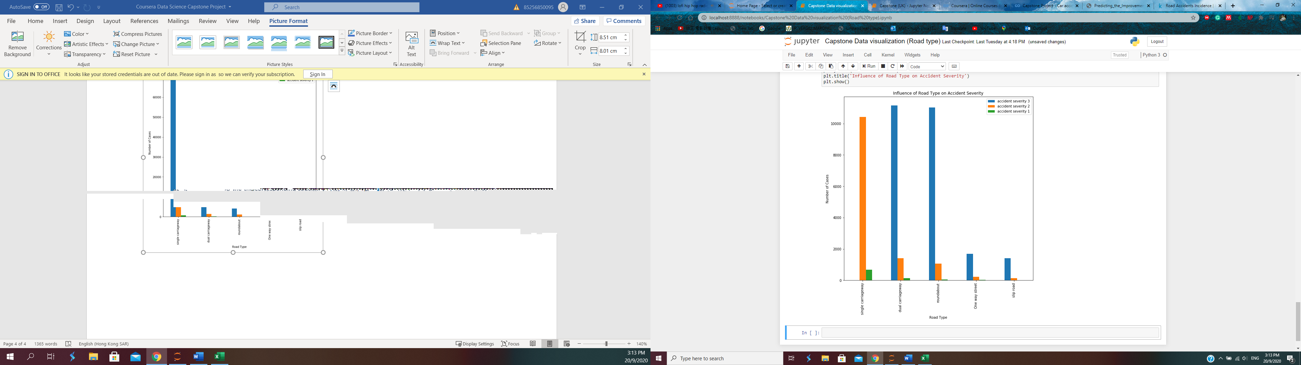

Figure : Influence of Road Type on Accident Severity, taking out the severity level 3 accidents that take place on single carriageways

## I hypothesized that most of the accidents would occur on major roads (carriageways), and less of them would occur on smaller roads (one-way roads, slip roads) because larger roads have faster-moving traffic. It is clear from figure 5 that most accidents occur on single carriageways, roughly four times the amount that dual carriageways and roundabouts have, which are its closest competitors. One-way streets and slip roads have approximately the same number of accidents. Most of the severity level 1 accidents occur on single carriageways as well, reinforcing the fact that single carriageways are the most dangerous. They are the most hazardous roads most likely since they bridge the gap between roads with fast-moving (e.g. dual carriageways) and slow-moving traffic (e.g. one-way roads). There would be a few junctions in between, which is when accidents occur. One-way street and slip roads have fewer accidents, most likely due to vehicles moving at a slower speed, which is what I predicted in my hypothesis.

## Junction Detail

|  |  |
| --- | --- |
| code | label |
| 0 | Not at junction or within 20 metres |
| 1 | Roundabout |
| 2 | Mini roundabout |
| 3 | T or staggered junction |
| 5 | Slip road |
| 6 | Crossroads |
| 7 | More than 4 arms (not roundabout) |
| 8 | Private drive or entrance |
| 9 | Other junction |
| -1 | Data missing or out of range |

After applying the exploratory data analysis method this graph is obtained:



Figure : Influence of the junction type on accident severity



Figure : Influence of the junction type on the accident severity w/out the largest value

## The most prominent finding is that there are very few accidents that occur more than 20m away from a junction (with only four accidents according to the dataset figure). This number of accidents seems too small when the dataset records data from 1979 to 2015. However, this is not unrealistic, as during the data cleaning phase after dropping all -1 values the number of rows went from 285331 to 1712125. This indicates that much data was lost, so it is entirely plausible that there are only four accidents under the no junction category.

## This seems to suggest that most accidents happen when drivers move from one road to another. T junctions by far have the most significant number of accidents (3x more than its closest competitor, which is crossroads), and have the most severity level 2 accidents by a large margin. This is followed up by accidents that occur on crossroads and roundabouts. Slip roads, mini roundabouts and 4+ arm junctions have significantly fewer accidents than t junctions, crossroads, and mini-roundabouts. This could be due to the slower moving traffic, where drivers have more time to react to possible traffic accidents. Private drives, however, seem to have a relatively large number of accidents for what should be slow-moving traffic. This could be due to several factors, such as driver complacency because they are used to the roads and junctions around it, private drives not having obvious junction points with other roads. Overall, it is clear that the presence of junctions significantly alters the probability of an accident occurring and its accident severity.

## Junction Control (given that there is a junction nearby)

|  |  |  |  |
| --- | --- | --- | --- |
| code | label |  |  |
| 0 | Not at junction or within 20 metres | | |
| 1 | Authorised person | |  |
| 2 | Auto traffic signal | |  |
| 3 | Stop sign |  |  |
| 4 | Give way or uncontrolled | | |
| -1 | Data missing or out of range | | |

Number code 0 denotes that there is no junction within 20m, however after removing the -1 values the only values that remain are 1, 2, 3, 4. Therefore the data for junction control is only true given that a junction is present.

Processing the data produces this graph:



Figure : How Junction Control influences number of cases and accident severity

## From this graph, we can see that most accidents occur when there is no controlled control. This makes sense as a traffic light is an apparent time to stop, whereas, with a give way line, there is much more uncertainty as to which car should or can move. It would seem that a stop sign is beneficial, but a driver is more likely to encounter traffic signals than stop signs in an average journey. The need for an authorized person to direct traffic is less than before, hence the low number of cases.

## Light conditions

|  |  |
| --- | --- |
| code | label |
| 1 | Daylight |
| 4 | Darkness - lights lit |
| 5 | Darkness - lights unlit |
| 6 | Darkness - no lighting |
| 7 | Darkness - lighting unknown |
| -1 | Data missing or out of range |

For this feature, rows with the value 7 were dropped as the lighting was unknown.

After data processing the graph produced is this:



Figure : How lighting condition affects accident severity and number of cases

From this graph, most traffic accidents occur when lighting is good. This is probably because most people drive during the daytime, and even when they drive at night the roads, they drive on roads that are well lit. There are very few roads that do not have traffic lights compared to those that do, hence the difference in the number of accidents.

## Weather Conditions

|  |  |
| --- | --- |
| code | label |
| 1 | Fine no high winds |
| 2 | Raining no high winds |
| 3 | Snowing no high winds |
| 4 | Fine + high winds |
| 5 | Raining + high winds |
| 6 | Snowing + high winds |
| 7 | Fog or mist |
| 8 | Other |
| 9 | Unknown |
| -1 | Data missing or out of range |

Labels ‘unknown’ and ‘other’ were dropped because they do not add value to the model.

Using the same method, this graph was produced:



Figure : How weather conditions affect accident severity

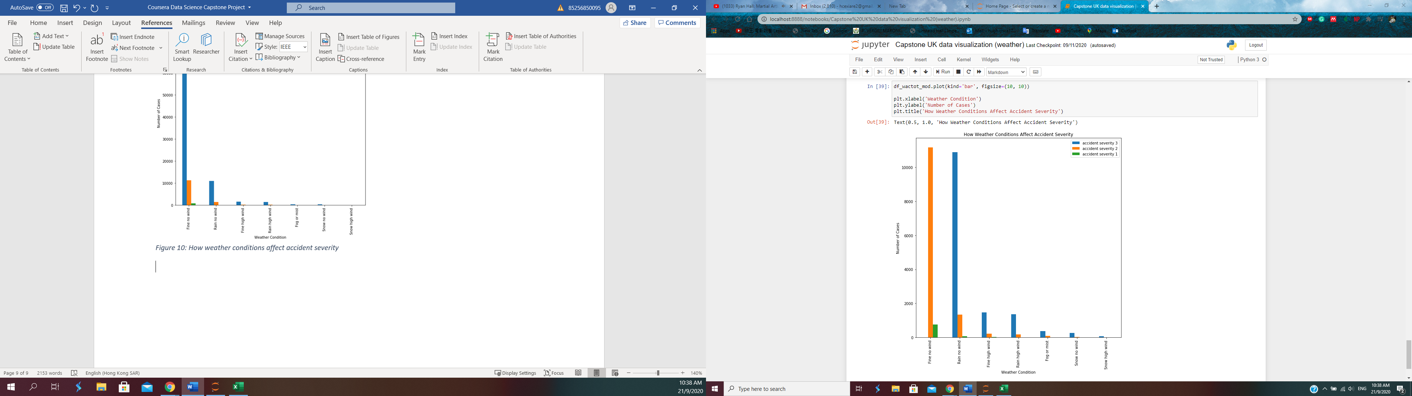

Figure : How weather conditions affect accident severity without accident severity 3 in ‘fine no wind’

## The vast majority of the accidents occur when the weather is fine, and there are no high winds. The following weather condition that produces the most casualties is rain with no high winds, roughly eight times lower than ‘fine no wind’. The other weather conditions have very few cases, but those weather conditions do not occur nearly enough for its’ value counts to be significant. Significantly for both weather conditions that involve snow. Snowing is an infrequent occurrence in the UK, hence a small number of cases. This data could give us a better idea of the possible event of an accident if we knew how often the weather is fine/raining/snowing in the UK. This is something that can be improved on if the project is taken further.

## Special Conditions

|  |  |
| --- | --- |
| code | label |
| 0 | None |
| 1 | Auto traffic signal - out |
| 2 | Auto signal part defective |
| 3 | Road sign or marking defective or obscured |
| 4 | Roadworks |
| 5 | Road surface defective |
| 6 | Oil or diesel |
| 7 | Mud |
| -1 | Data missing or out of range |

After applying the exploratory data analysis method, the following graph was obtained:

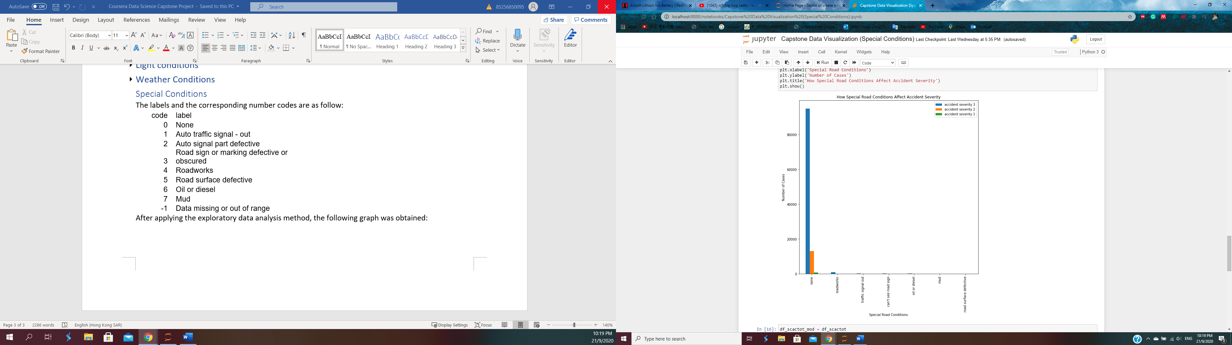

Figure : Influence of Special Road Conditions on traffic accident cases

From this graph, it is clear that the special road conditions listed do little to affect the traffic accident severity or the number of cases.

## Road Surface

The labels and the corresponding numerical codes are displayed below:

|  |  |
| --- | --- |
| code | label |
| 1 | Dry |
| 2 | Wet or damp |
| 3 | Snow |
| 4 | Frost or ice |
| 5 | Flood over 3cm. deep |
| 6 | Oil or diesel |
| 7 | Mud |
| -1 | Data missing or out of range |



Figure : Influence of Road Surface condition on accident severity

From this graph, most traffic accidents occur under dry circumstances. As the UK snows very little and does not often have torrential downpour, there are very few cases attributing to ‘frost or ice’, ‘snow’, or ‘flood’. However, a significant number of accidents do occur under wet or damp conditions, making it a substantial factor in determining if an accident will occur.

## Day of week

|  |  |
| --- | --- |
| code | label |
| 1 | Sunday |
| 2 | Monday |
| 3 | Tuesday |
| 4 | Wednesday |
| 5 | Thursday |
| 6 | Friday |
| 7 | Saturday |

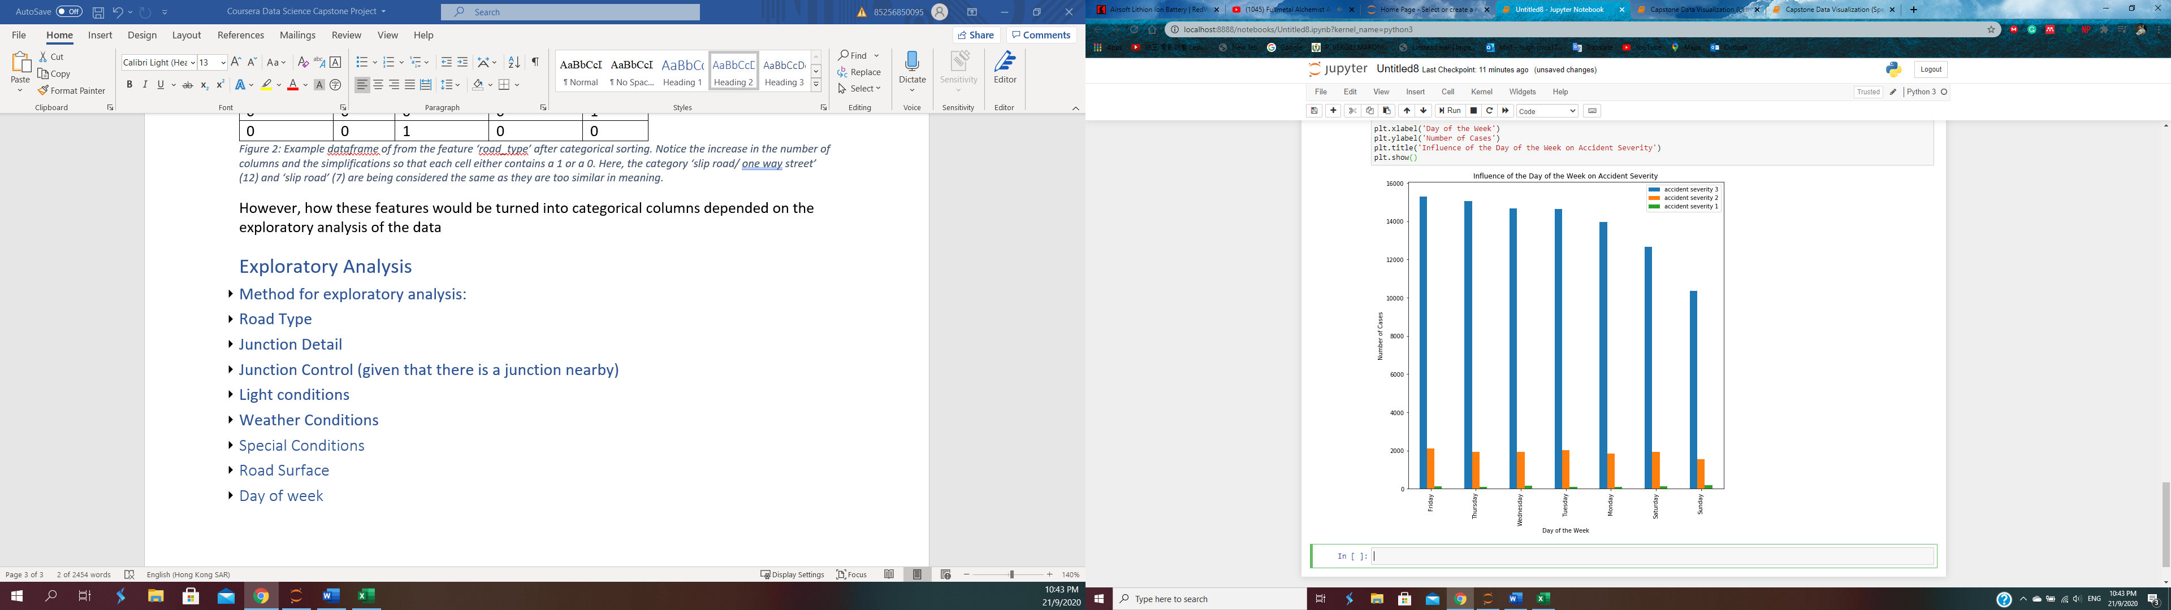

Figure : Influence of the day of the week on the number of cases

## From this graph, we can see that Saturday and Sunday have fewer accidents overall than the weekdays, with Friday being the day with the most accidents with a severity of 3. This is in line with conventional thinking as more trips are made during the week, especially for work. Most of the severity level 2 accidents have roughly the same distribution day to day. An interesting thing to note is that Sunday has the highest number of accidents with severity level 1. A possible explanation for this is the “weekend driver” who only drives during the weekend and thus is less competent than someone who drives during the week. In the model, it could be beneficial to group weekdays and weekends together, as there is not much difference within the categories.

## Urban or Rural

The labels and the corresponding numbered codes are shown below:

|  |  |
| --- | --- |
| code | label |
| 1 | Urban |
| 2 | Rural |
| 3 | Unallocated |

After applying exploratory data analysis this graph is produced:



Figure : How the type of area influences number of accidents

From the graph more traffic accidents occur in urban areas. Very severe accidents do occur in rural areas more, but it only occurs slightly more, and should not be considered as a significant difference. This is most likely the case as urban areas are much more densely populated and would have a higher concentration of vehicles.

# Data Processing

A heatmap showing the linear correlation between different features is created using the seaborn library.



Figure : A heatmap comparing all the features in the dataset

# The heatmap produced shows the linear correlation between attributes. A dark purple cell indicates 0 correlation between 2 attributes, while a white cell indicates a perfect correlation. From the heatmap, we can see that there is no positive linear correlation present apart from ‘light_conditions’, ‘weather_conditions’ and ‘road_surface_conditions’. These make sense as to whether it rains or not will directly affect the road conditions. There is not much correlation between any of the other attributes. Therefore, there is no need for machine learning models based on linearity.

# Predictive modelling

## As discussed in the data processing section, the different features have a low correlation to each other, and it is therefore not beneficial to apply any sort of linear modelling. The classification models are more appropriate for finding out the accident severity of a particular accident than linear modelling. However, the regression models might be more appropriate to find the increase or decrease in the number of accidents based on a category in a feature.

## To conduct predictive modelling, the best settings for each model would have to be found before the models are applied. At the very start of the data feature selection process, we have already split the original dataset into two, one that does not contain information on junctions (df1) and one that does contain that information on junctions (df2). These two datasets were further split. Df1 was divided into df1 and df_a, where df1 was used to find out the best settings, and df_a was used to test the models. Df2 was similarly split into df2 and df_b for the same purposes. Each one of the split datasets (df1, df2, df_a, df_b) has 12000 rows. Once the optimum parameters were found, the entire df1 and df2 data were implemented into the machine learning models as training data, and the df_a and df_b datasets were used as testing data.

## K Nearest Neighbours

K nearest neighbours is a very common algorithm that classifies new data based on its distance function to other points. The main parameter is the value ‘k’, which refers to the number of nearest neighbours to include in the majority of the selection process to determine which category a new data point is a part of. In this case, cross-validation was used for k values 3-10 to determine the best accuracy. Values 3-10 represent the consensus best range for a k value. For df1 (without junction) the K value was 9, but for df2 (with junction) this value was 10.

## Decision Tree

## Decision Tree is another widespread algorithm that can be used for both regression and classification. It does this by learning decision rules obtained from the training data. The main parameter with this algorithm is the maximum depth, which is the maximum depth of the decision tree that can be created. Once again, this is done by cross-validation between a range of numbers from 3 to 10. In the end, the best maximum depth for both df1 and df2 was 9.

## Support Vector Machine

## Another commonly used algorithm used in machine learning; this algorithm works by trying to find the best hyperplane between two clusters of data. The possible variables this case are the types of kernels. 4 types of kernels were tested using cross-validation, those being linear, polynomial, radial basis function (RBF), and sigmoid. For df1 (no junction) the RBF kernel was selected, but for df2 the linear kernel was selected.

## Logistic Regression

# Logistic regression is an extension of linear regression but is designed for classification problems. The variables this time are the c value and the solver. The c parameter is the inverse of regularization strength which is a positive float. The solvers include ‘newton-cg’, ‘lbfgs’, ‘liblinear’, ‘sag’, ‘saga’, which are numerical optimizers. After cross-validation, it was found that c=0.0001 and ‘liblinear’ were the best parameters for both datasets.

# Results

The accuracy scores of each model with and without junction information are included in the table below:



Figure : Table showing all the machine learning models, and the corresponding accuracy values with and without data for junctions.

# The accuracy values determined with junction information all seem to be slightly smaller than the values determined without junction information, but for all purposes, they are the same values. This indicates that the addition of the junction values did not affect the model accuracy. This could be because the model already had a large amount of data from other attributes to train on, so it did not necessarily need the junction information to predict the accident severities.

# In the future different machine learning models could be used, such as Random forest, gradient boost. More data could be used, but the effectiveness of this step is highly questionable as 12000 data points is already a relatively large dataset. More attributes could also be looked at, such as the age of the driver, the age of the vehicle, et cetera.

# Conclusion

In this project, I hypothesized that knowledge of junctions and different junction types near a traffic accident site would improve the ability of a machine learning model to predict the number of accidents and accident severity. I sought out to do this by creating two datasets, one without junction data and one with junction data. I trained both datasets using standard machine learning algorithms, found the optimum settings for them, then compared the predicted outcomes to other parts of the original dataset. What I found was that data on the junctions does not alter the prediction accuracy of the model.